WhatNext Vision Motors: Shaping the Future of Mobility with Innovation and Excellence

Use Case :
WhatsNext Vision Motors, a pioneering force in the automotive industry, is dedicated to transforming the mobility sector with innovative technology and solutions that prioritize customer needs. The company has embarked on an ambitious Salesforce project with the core objective of enhancing the customer experience and streamlining its operational processes.
At the heart of this project is the improvement of the customer ordering process. The system is designed to automatically suggest the nearest dealer location to customers based on their address. This feature is intended to significantly enhance the convenience and efficiency of the ordering experience, making it more customer-friendly and reducing the time and effort required from the customer’s end.
The project also addresses a common issue in the automotive industry: stock availability. The system includes a mechanism that prevents customers from placing orders for vehicles that are out of stock. This proactive approach ensures that customers can only create orders for vehicles that are currently available, thus avoiding potential confusion and disappointment that may arise from stock unavailability. This feature not only enhances customer satisfaction but also improves the accuracy of the company’s order fulfillment process.
Furthermore, the project incorporates a scheduled process for updating the status of bulk order records. This automated process is designed to update the order status based on stock availability. If a vehicle is out of stock at the time of order placement, the system will update the order status to ‘Pending’. On the other hand, if the vehicle is in stock, the system will update the status to ‘Confirmed’. This ensures that all orders are accurately reflected in terms of their fulfillment status, providing clear and transparent communication to customers regarding the status of their orders.
The implementation of this Salesforce project at WhatsNext Vision Motors is expected to yield several benefits. It aims to create a more efficient ordering system that reduces the potential for errors and improves the overall service provided to customers. By streamlining the ordering process and ensuring accurate stock availability, the company can enhance customer satisfaction and loyalty.
Moreover, the project is expected to contribute to operational efficiency by reducing the administrative burden on staff. By automating certain processes, employees can focus on more strategic tasks that require human intervention and expertise. This not only improves the overall productivity of the company but also allows for a more agile response to market demands and customer needs.

Requirements :

1. Salesforce CRM Implementation
- Store and manage vehicle details, stock availability, and dealer information in Salesforce.
- Track customer orders, test drives, and service requests efficiently.
- Automate workflows to assign orders to the nearest dealer based on customer location.

2. Process Automation
- Prevent order placement if the vehicle is out of stock.
- Auto-assign orders to the nearest dealer based on the customer’s location.
- Send automated email reminders for scheduled test drives.

3. Apex and Trigger
- Implement Apex triggers to enforce business rules such as stock validation and automatic dealer assignment.
- Use trigger handlers to follow best practices and ensure modularity and maintainability.

4. Batch Jobs
- Develop a batch Apex job to periodically check vehicle stock levels and update availability.
- Send scheduled email notifications for stock replenishment and order processing.

What you’ll learn :
1. Data Modelling
2. Fields and Relationships
3. Lightning App Builder
4. Record Triggered Flows
5. Apex and Apex Triggers
6. Batch Apex
7. Scheduled Apex

Phase Overview :
Phase | Title (Milestone) | Key Outcome
1 | Creating Developer Account | Salesforce Developer Edition org created, activated and accessed
2 | Objects & Relationships | Six custom objects defined; Vehicle and Dealer objects created
3 | Tabs | Custom object tabs created for the objects
4 | The Lightning App | “WhatNext Vision Motors” app with navigation items and profile access
5 | Fields & Relationships | Picklist, number and lookup fields added to the Vehicle object
6 | Process Automation (Flows) | Auto Assign Dealer and Test Drive Reminder flows activated
7 | Apex, Trigger and Batch Jobs | Stock-validation trigger, batch job and schedule in place

Phase 1 : Creating Developer Account

Objective
To create and activate a Salesforce Developer Edition org, which is used as the development environment for the whole project.

Activities Completed
- Activity 1: Creating Developer Account
- Activity 2: Account Activation

Implementation Details

Activity 1: Creating Developer Account
Creating a developer org in Salesforce.
1. Go to https://developer.salesforce.com/signup
2. On the sign-up form, enter the following details:
- First name & Last name
- Email
- Role : Developer
- Company : College Name
- Country : India
- Postal Code : pin code
- Username : should be a combination of your name and company
This need not be an actual email id, you can give anything in the format: username@organization.com. Click on “Sign me up” after filling in these details.
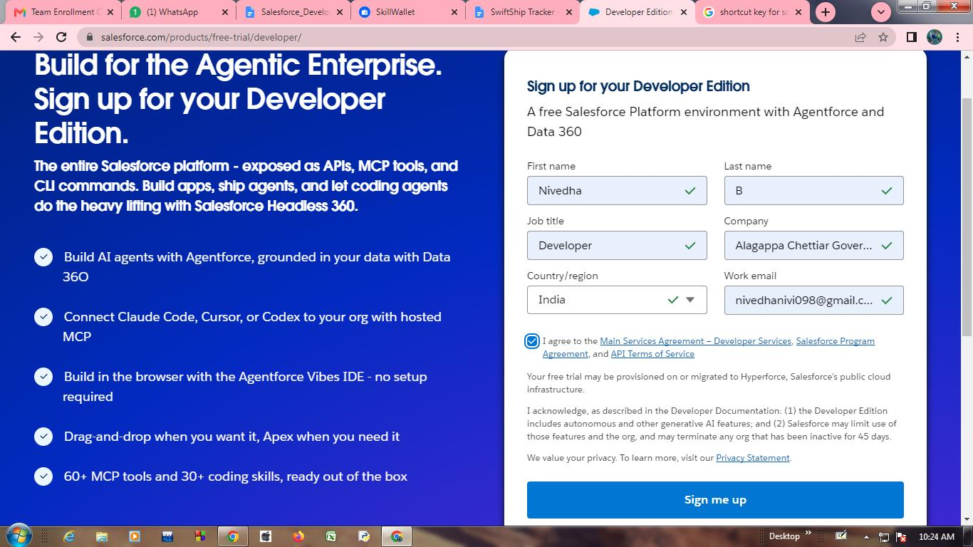
Figure 1: Developer Edition sign-up form
The sign-up form filled with first name, last name, job title (Developer), company, country/region (India) and work email, with the agreement accepted, before clicking “Sign me up”.

Activity 2: Account Activation
1. Go to the inbox of the email that you used while signing up and open the Salesforce welcome email. Click on the verification / reset-password link. The email may take 5–10 minutes to arrive.
2. Click on Verify Account (Reset Password).
3. Give a password, answer a security question and click on Change Password.
4. You will then be redirected to your Salesforce Setup page.
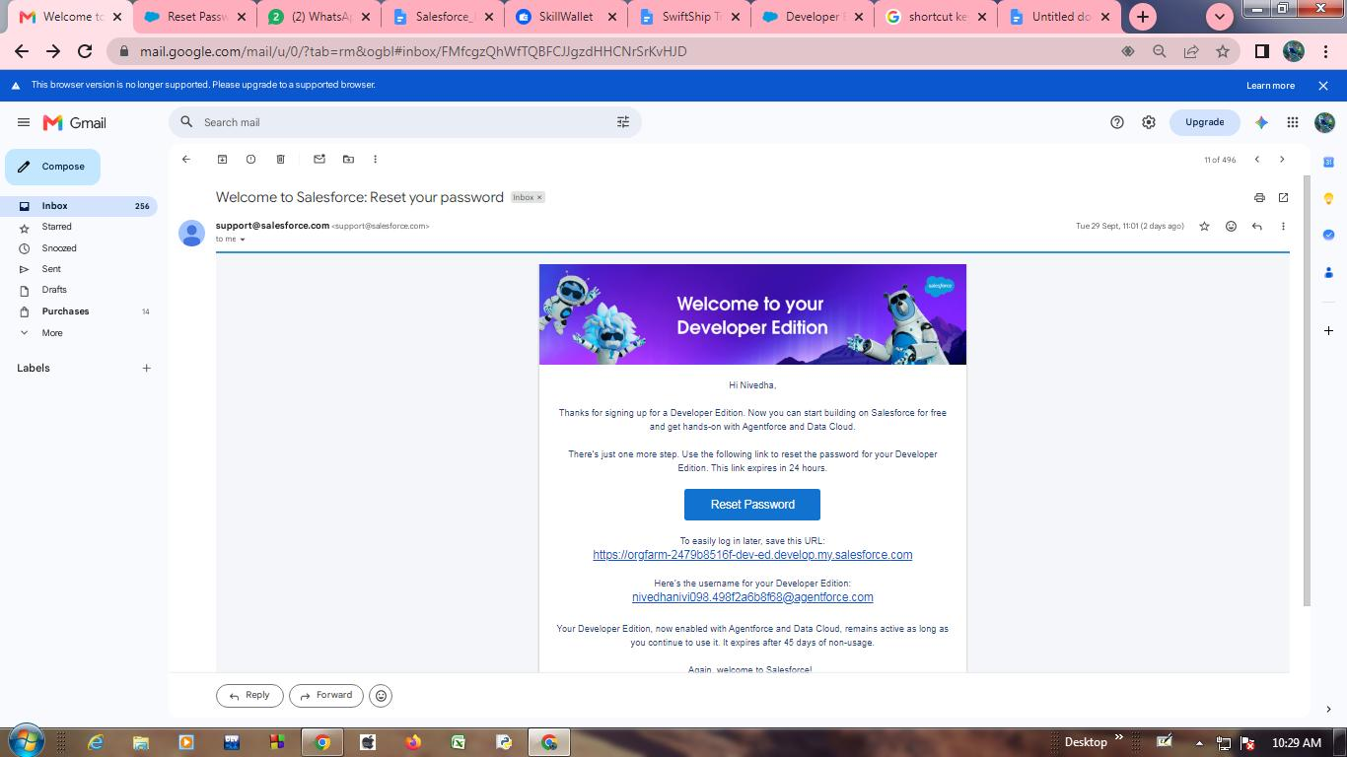
Figure 2: Welcome email from Salesforce
The welcome email contains the link to reset the password, the org login URL and the username of the new Developer Edition org.
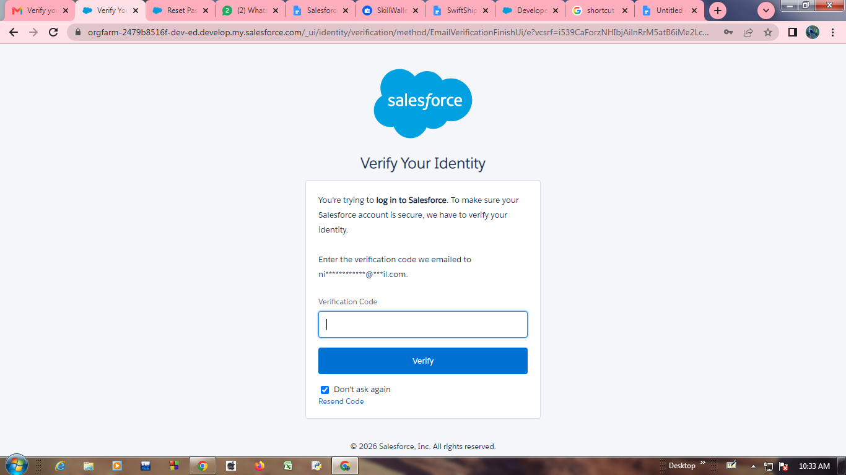
Figure 3: Verify Your Identity
On first login Salesforce asks for the verification code that was emailed to the registered address.
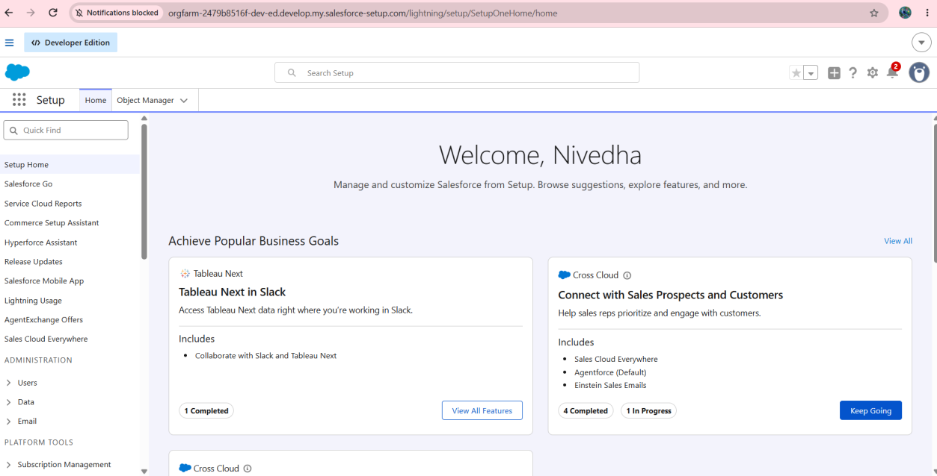
Figure 4: Salesforce Setup home page
After verification the Setup home page opens, confirming that the org is active and ready for configuration.

Features / Modules Involved
- Salesforce Developer Edition org, email verification, password set-up and Setup home.

Output / Result
A Developer Edition org was created and activated, and the Setup page is accessible. All the following phases are carried out in this org.

Phase 2 : Objects & Relationships

Objective
To model the application data by creating the custom objects used to store vehicles, dealers, customers, orders, test drives and service requests.

Activities Completed
- Activity 1: Create Vehicle Object
- Activity 2: Create Dealer Object
- Activity 3: Creating remaining objects

Objects & Relationships
Object Name | Purpose | Relationships
Vehicle__c | Stores vehicle details | Related to Dealer & Orders
Vehicle_Dealer__c | Stores authorized dealer info | Related to Orders
Vehicle_Customer__c | Stores customer details | Related to Orders & Test Drives
Vehicle_Order__c | Tracks vehicle purchases | Related to Customer & Vehicle
Vehicle_Test_Drive__c | Tracks test drive bookings | Related to Customer & Vehicle
Vehicle_Service_Request__c | Tracks vehicle servicing requests | Related to Customer & Vehicle

Implementation Details

To Navigate to Setup page
Click on the gear icon → click Setup.
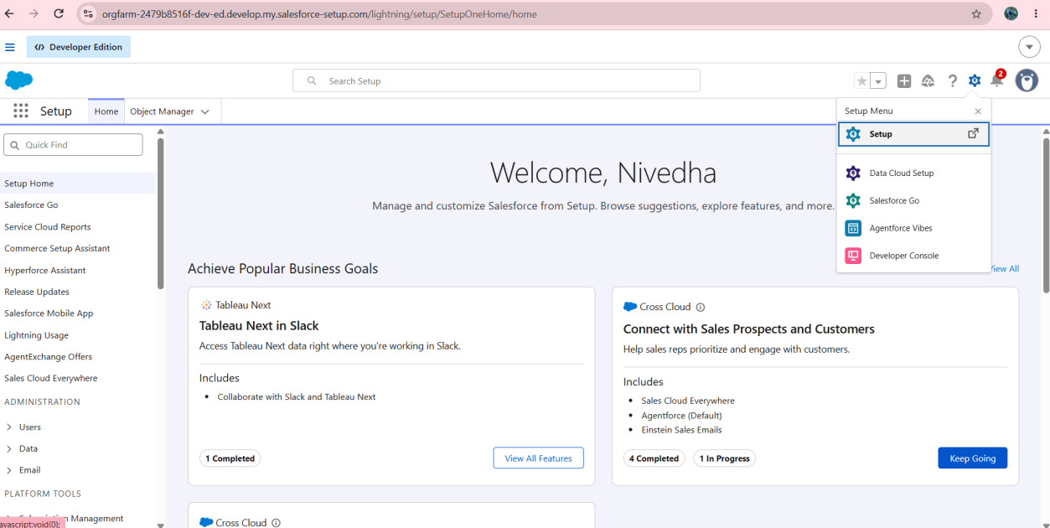
Figure 5: Navigating to Setup
The gear icon opens the Setup menu, from which Setup is selected.

Activity 1: Create Vehicle Object
The purpose of creating a Vehicle custom object is to have a clear picture of the vehicle details. To create an object:
1. From the Setup page → click on Object Manager → click on Create → click on Custom Object.
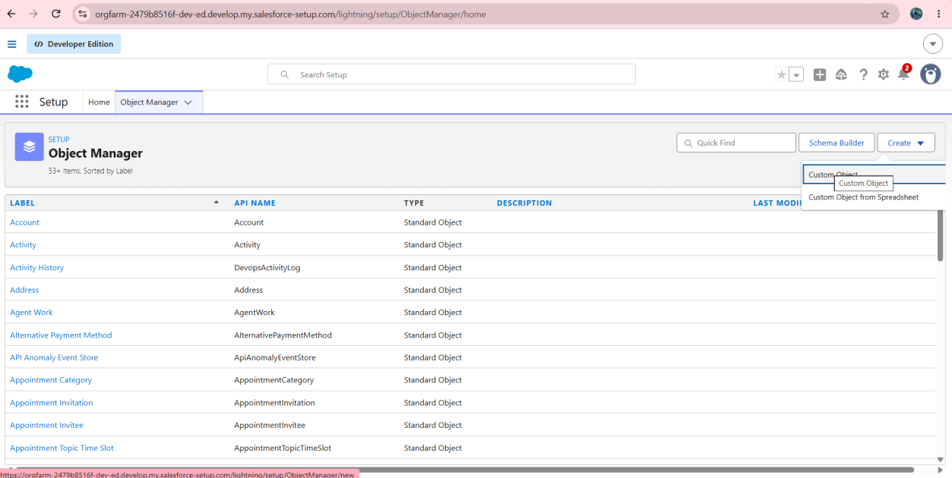
Figure 6: Object Manager – Create → Custom Object
The Create menu in Object Manager offers the Custom Object option used to define each new object.
Then fill in the object details:
- Enter the label name → Vehicle
- Plural label name → Vehicles
- Enter Record Name Label and Format: Record Name → Vehicle Name; Data Type → Text
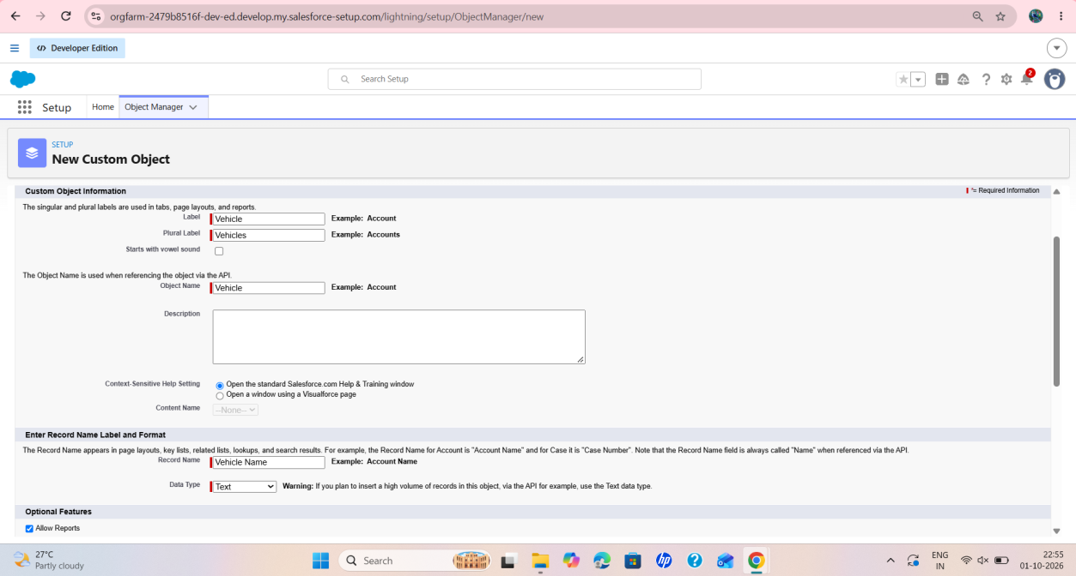
Figure 7: New Custom Object – Vehicle
The New Custom Object form with label “Vehicle”, plural label “Vehicles”, object name “Vehicle” and record name “Vehicle Name” with data type Text.
2. Click on Allow Reports.
3. Allow Search → Save.
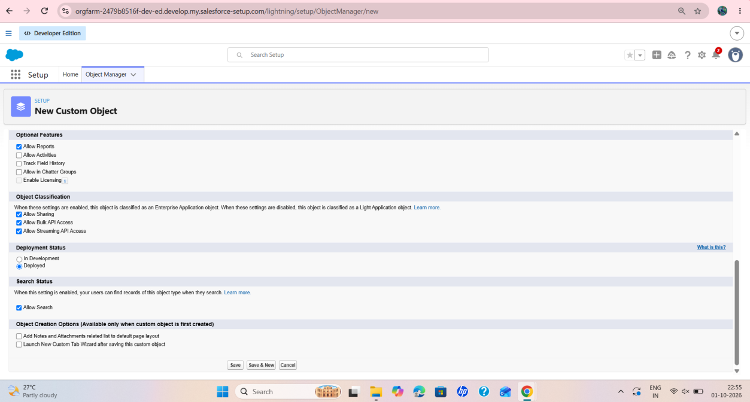
Figure 8: Optional features and search status
“Allow Reports” and “Allow Search” are selected and the deployment status is Deployed, before saving the object.

Activity 2: Create Dealer Object
The purpose of creating a Dealer object is to have detailed information about the dealer. To create an object:
1. From the Setup page → click on Object Manager → click on Create → click on Custom Object.
2. Enter the label name → Vehicle Dealer; plural label name → Vehicle Dealers.
3. Enter Record Name Label and Format: Record Name → Dealer Name; Data Type → Text.
4. Click on Allow Reports.
5. Allow Search → Save.

Activity 3: Creating remaining objects
The remaining objects listed in the table above – Vehicle Customer, Vehicle Order, Vehicle Test Drive and Vehicle Service Request – are created in the same way.

Features / Modules Involved
- Object Manager, custom objects, record name settings, reports and search options.

Output / Result
The custom objects required for the project were created and deployed, forming the data model of the application.

Phase 3 : Tabs

Objective
To create custom tabs so that the records of each custom object can be opened from the Salesforce interface.

Activities Completed
- Activity 1: Creating a Custom Tab (Vehicle)
- Activity 2: Creating tabs for the other objects

Implementation Details

Activity 1: Creating a Custom Tab (Vehicle)
1. Go to the Setup page → type Tabs in the Quick Find bar → click on Tabs → New (under Custom Object Tabs).
2. Select the Object (Vehicle) → select any tab style → Next (Add to profiles page) keep it as default → Next (Add to Custom App) keep it as default → Save.
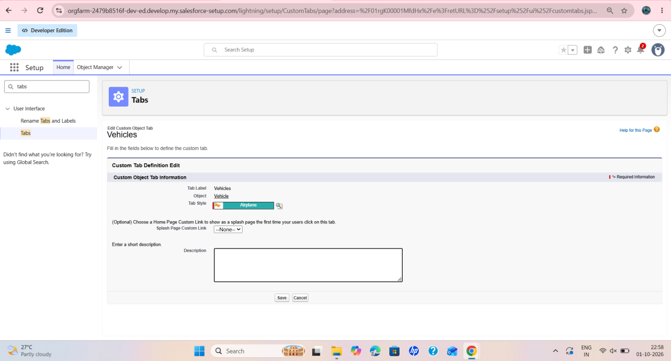
Figure 9: Custom Object Tab – Vehicles
The tab definition shows the tab label “Vehicles”, the object Vehicle and the selected tab style.

Activity 2
Now create tabs for the other objects as well, which were created in the previous phase.

Features / Modules Involved
- Custom Tabs (Custom Object Tabs) and tab styles.

Output / Result
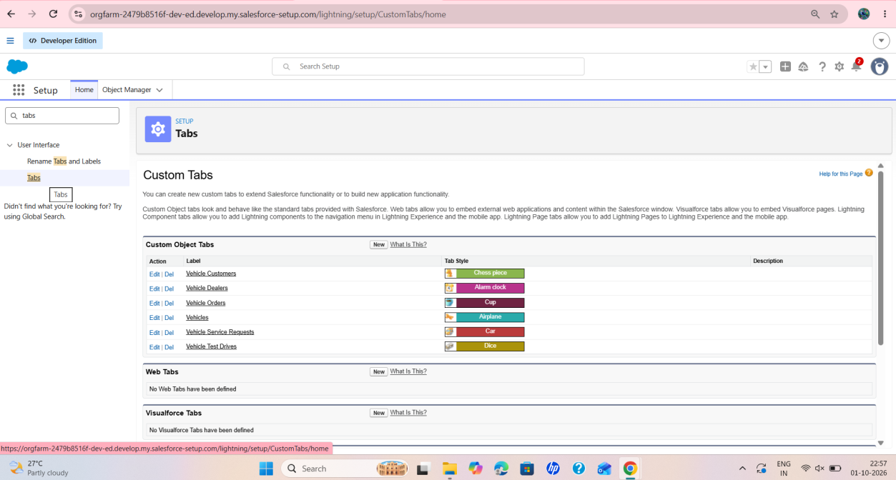
Figure 10: Custom Object Tabs list
The Custom Object Tabs section lists the tabs for Vehicle Customers, Vehicle Dealers, Vehicle Orders, Vehicles, Vehicle Service Requests and Vehicle Test Drives, each with its own tab style.
Custom tabs were created for the objects and are ready to be added to the Lightning app.

Phase 4 : The Lightning App

Objective
To build a Lightning app named “WhatNext Vision Motors” that brings the project objects, reports and dashboards together in one place.

Activities Completed
- Activity 1: Create a Lightning App

Implementation Details

Activity 1: Create a Lightning App
To create a Lightning app page:
1. Go to the Setup page → search “App Manager” in Quick Find → select “App Manager” → click on New Lightning App.
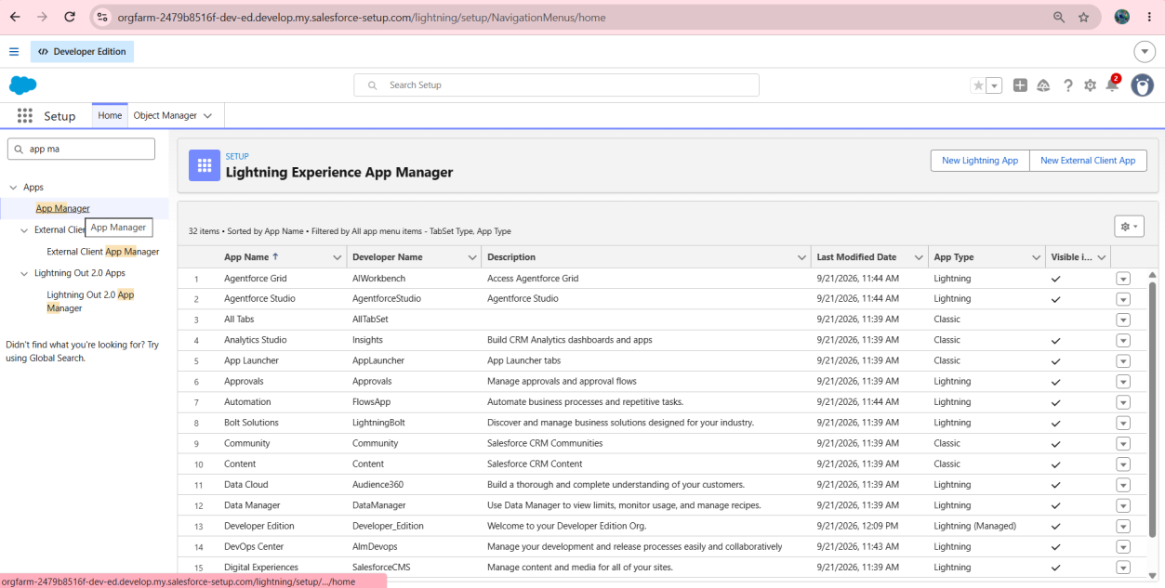
Figure 11: Lightning Experience App Manager
The App Manager lists the existing apps and provides the “New Lightning App” button.
2. Fill the app name in App Details and Branding as follows: App Name : WhatNext Vision Motors; Developer Name : this will be auto populated; Description : give a meaningful description; Image : optional (not mandatory); Primary color hex value : keep this default.
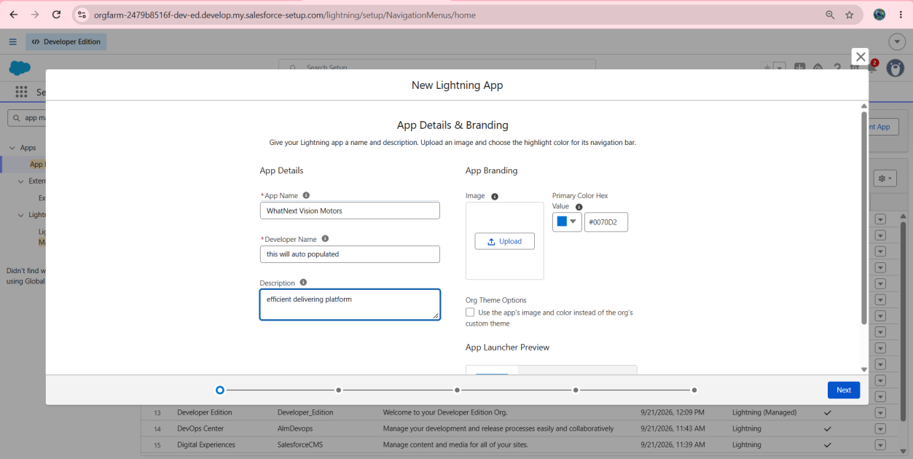
Figure 12: App Details & Branding
The new Lightning app is named “WhatNext Vision Motors”, with an auto-populated developer name and a short description.
3. Then click Next → (App Options page) keep it as default → Next → (Utility Items) keep it as default → Next.
4. To add Navigation Items: search the items in the search bar (Vehicle, Dealer, Customer, Order, Test Drive, Service Request, Reports, Dashboard) and move them using the arrow button → Next. Note: select the custom objects which were created in the previous activity.
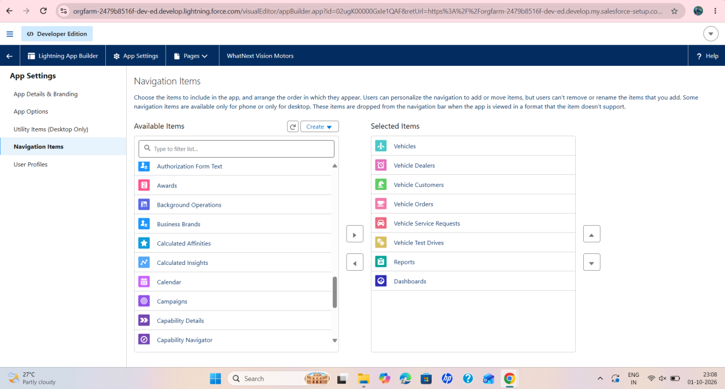
Figure 13: Navigation items
The selected items are Vehicles, Vehicle Dealers, Vehicle Customers, Vehicle Orders, Vehicle Service Requests, Vehicle Test Drives, Reports and Dashboards.
5. To add User Profiles: search the profile (System Administrator) in the search bar → click on the arrow button → Save & Finish.
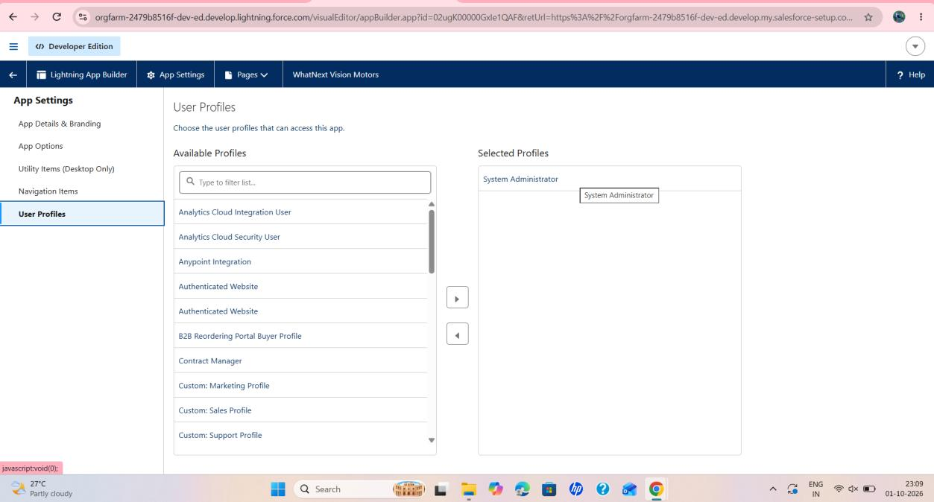
Figure 14: User profiles
The System Administrator profile is moved to Selected Profiles so that it can access the app.

Features / Modules Involved
- App Manager, Lightning App Builder, navigation items and profile-based access.

Output / Result
The “WhatNext Vision Motors” Lightning app was created with navigation to the project objects, reports and dashboards, and is available to the System Administrator profile.

Phase 5 : Fields & Relationships

Objective
To add the key fields to each object and define the relationships between the objects.

Activities Completed
- Activity 1: Creating a Field in Vehicle Object
- Activity 2: Creating Stock Quantity field in Vehicle Object
- Activity 3: Creating a Lookup Relationship in Vehicle Object to Dealer Object
- Activity 4: Creating remaining objects and fields

Key Fields for Each Object

1. Vehicle__c (Custom Object)
- Vehicle Name (Text)
- Vehicle_Model__c (Picklist: Sedan, SUV, EV, etc.)
- Stock_Quantity__c (Number)
- Price__c (Currency)
- Dealer__c (Lookup to Dealer__c)
- Status__c (Picklist: Available, Out of Stock, Discontinued)

2. Vehicle_Dealer__c (Custom Object)
- Dealer_Name__c (Text)
- Dealer_Location__c (Text)
- Dealer_Code__c (Auto Number)
- Phone__c (Phone)
- Email__c (Email)

3. Vehicle_Order__c (Custom Object)
- Vehicle_Customer__c (Lookup to Vehicle_Customer__c)
- Vehicle__c (Lookup to Vehicle__c)
- Order_Date__c (Date)
- Status__c (Picklist: Pending, Confirmed, Delivered, Canceled)

4. Vehicle_Customer__c (Custom Object)
- Customer_Name__c (Text)
- Email__c (Email)
- Phone__c (Phone)
- Address__c (Text)
- Preferred_Vehicle_Type__c (Picklist: Sedan, SUV, EV, etc.)

5. Vehicle_Test_Drive__c (Custom Object)
- Vehicle_Customer__c (Lookup to Vehicle_Customer__c)
- Vehicle__c (Lookup to Vehicle__c)
- Test_Drive_Date__c (Date)
- Status__c (Picklist: Scheduled, Completed, Canceled)

6. Vehicle_Service_Request__c (Custom Object)
- Vehicle_Customer__c (Lookup to Vehicle_Customer__c)
- Vehicle__c (Lookup to Vehicle__c)
- Service_Date__c (Date)
- Issue_Description__c (Text)
- Status__c (Picklist: Requested, In Progress, Completed)

Implementation Details

Activity 1: Creating a Field in Vehicle Object
1. Go to Setup → click on Object Manager → type the object name (Vehicle) in the Quick Find bar → click on the object.
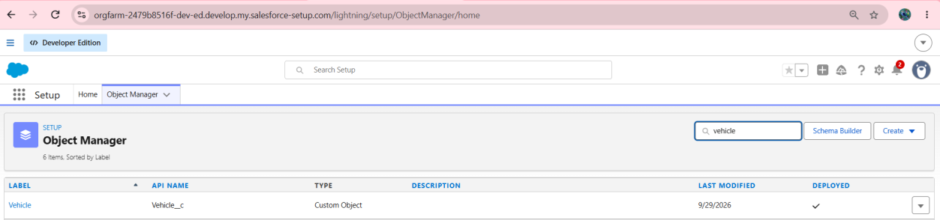
Figure 15: Vehicle object in Object Manager
Searching for “vehicle” lists the Vehicle object (API name Vehicle__c, type Custom Object, Deployed).
2. Now click on “Fields & Relationships” → New.
3. Select Data type as “Picklist”.
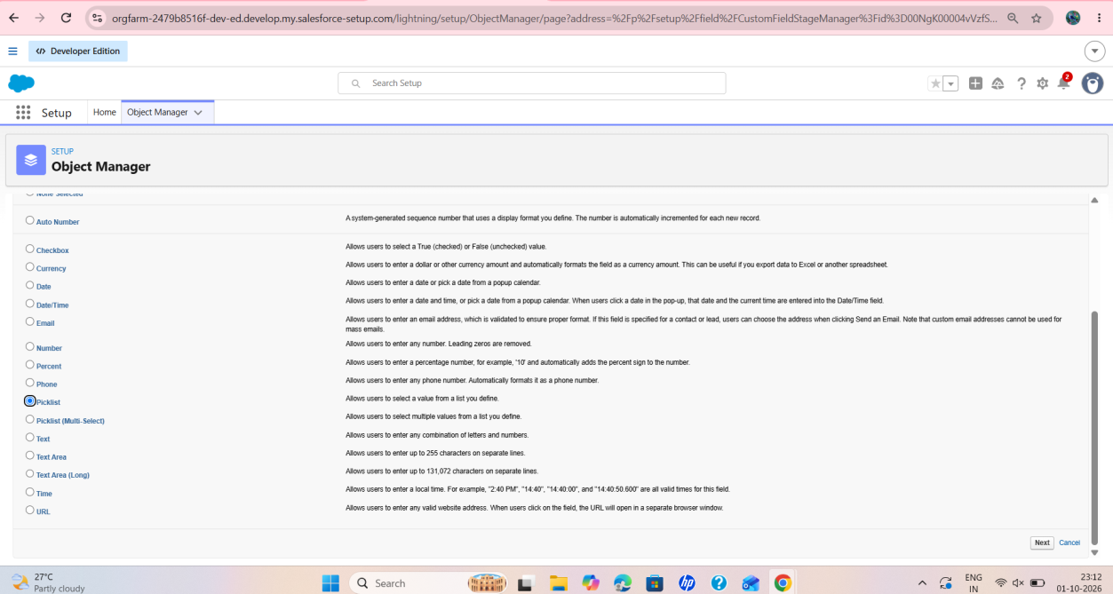
Figure 16: Choosing the Picklist data type
The Picklist data type is selected in step 1 of the new custom field wizard.
4. Click on Next.
5. Fill in the details: Field Label: Vehicle Model; fill in the picklist values; click on Next → Next → Save & New.
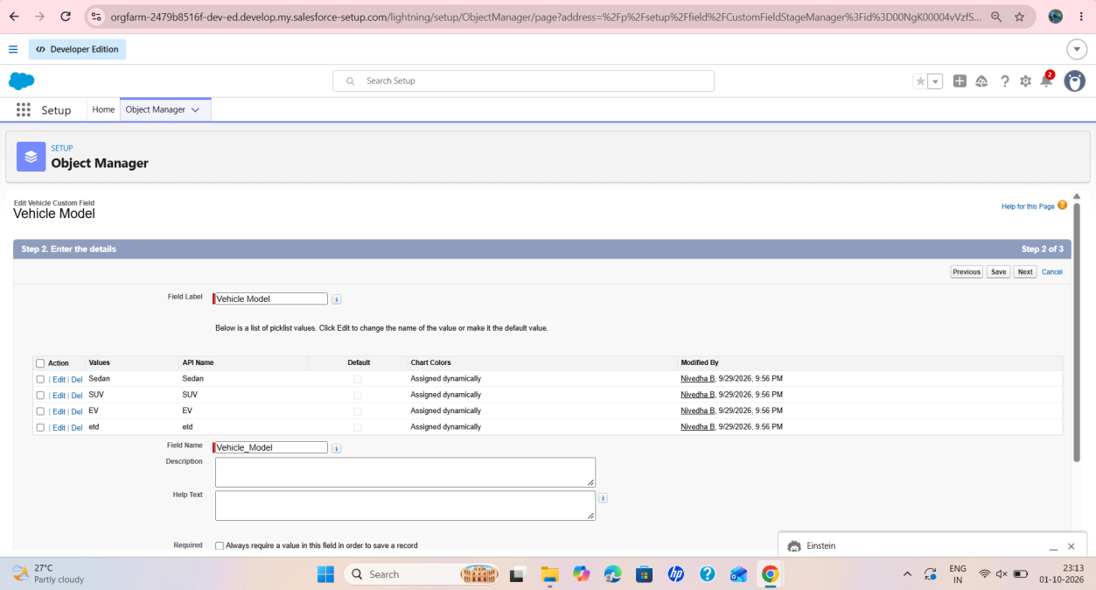
Figure 17: Vehicle Model picklist field
The Vehicle Model picklist lists the values Sedan, SUV, EV and etc.; the generated field name is Vehicle_Model.

Activity 2: Creating Stock Quantity field in Vehicle Object
1. Repeat steps 1 and 2 from Activity 1.
2. Select Data type as “Number”.
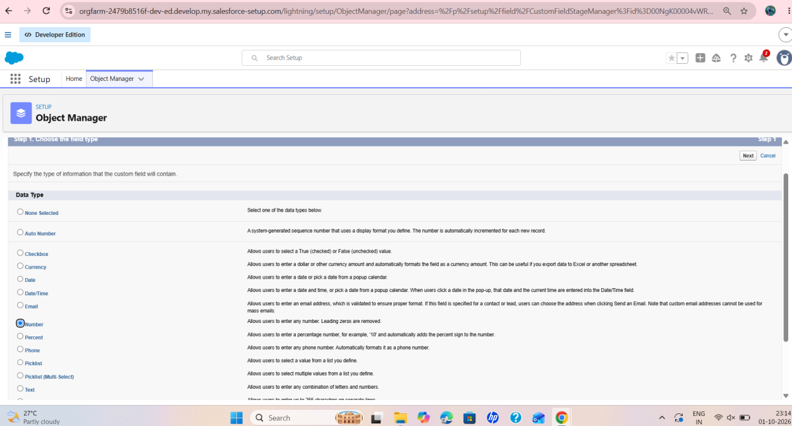
Figure 18: Choosing the Number data type
The Number data type is selected in step 1 of the field wizard.
3. Click on Next.
4. Fill in the details: Field Label: Stock Quantity; click on Next → Next → Save & New.
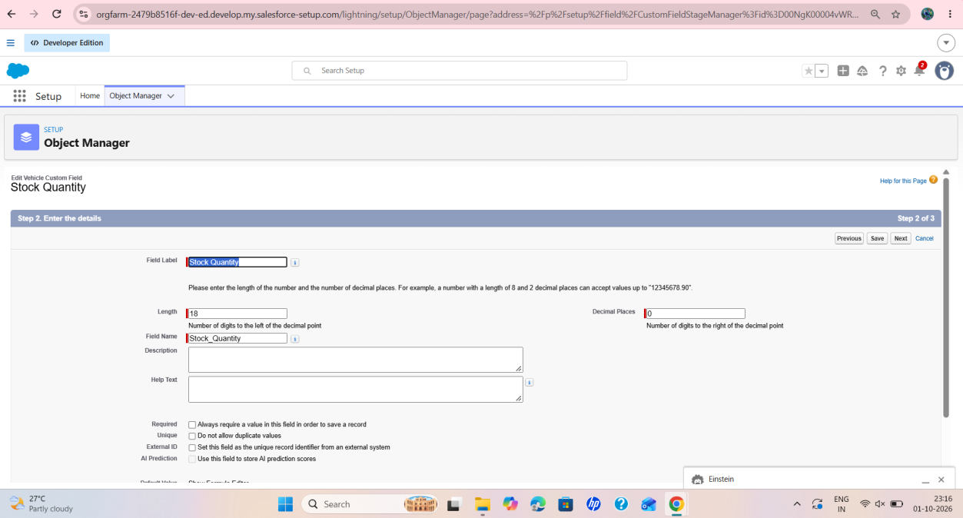
Figure 19: Stock Quantity field
The Stock Quantity field is a Number with length 18 and 0 decimal places.

Activity 3: Creating a Lookup Relationship in Vehicle Object to Dealer Object
1. Select Data Type as Lookup Relationship.
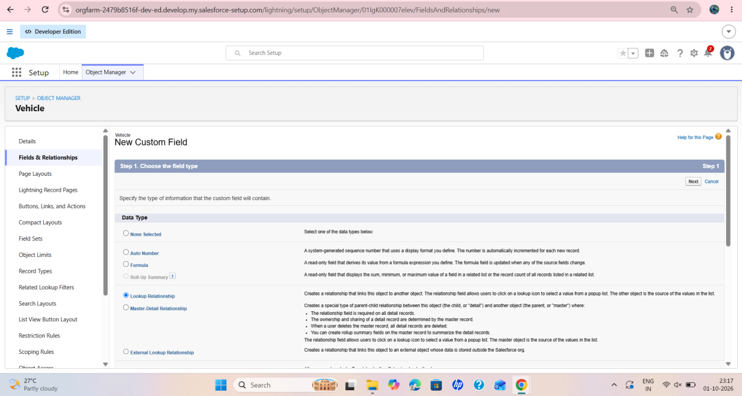
Figure 20: Choosing Lookup Relationship
The Lookup Relationship data type is selected on the Vehicle object’s new custom field page.
2. Click Next.
3. Select the Dealer object in the Related To field.
4. Click Next and Save (enter the field label and name “Dealer”, keep the field-level security as default and continue with Next).
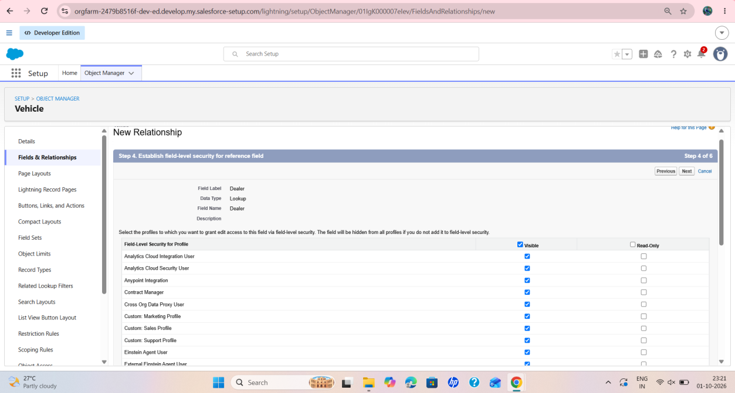
Figure 21: Dealer lookup – field-level security
Step 4 of the relationship wizard: the field label “Dealer”, data type Lookup, and the profiles for which the field is visible.

Activity 4: Creating Remaining Objects and Fields
The remaining fields listed under Key Fields for Each Object are created in the same way for each object.

Features / Modules Involved
- Fields & Relationships, picklist, number and lookup field types and field-level security.

Output / Result
The Vehicle object holds a model picklist, a stock quantity and a dealer lookup, and the remaining objects were given the fields needed to relate customers, vehicles, orders, test drives and service requests.

Phase 6 : Process Automation (Flows)

Objective
To automate dealer assignment for new orders and to send reminder emails for scheduled test drives by using record-triggered flows.

Activities Completed
- Flow 1: Creating a record-triggered flow to assign the nearest dealer to the customer’s location
- Flow 2: Creating a record-triggered flow to send an email to the customer reminding about the test drive

Implementation Details

Flow 1: Creating a record-triggered flow to assign the nearest dealer to the customer’s location
Step 1 : In Quick Find, type Flows and click on Flows. Click New Flow.
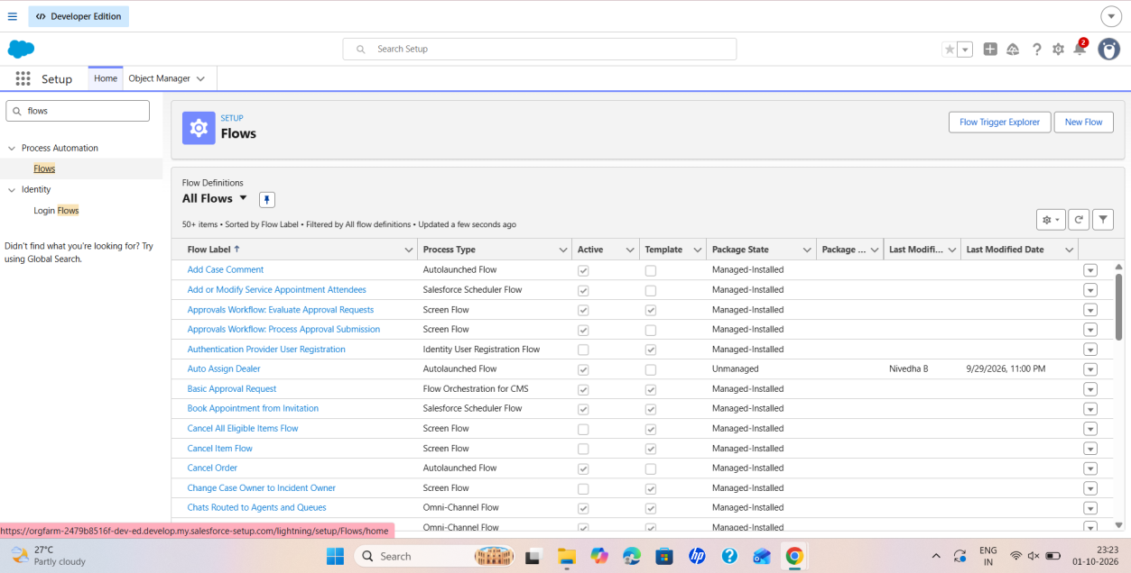
Figure 22: Flows page
The Flows page in Setup lists the existing flows and provides the New Flow button.
Step 2 : Select Triggered Automation from Flow.
Step 3 : Select Record-Triggered Flow.
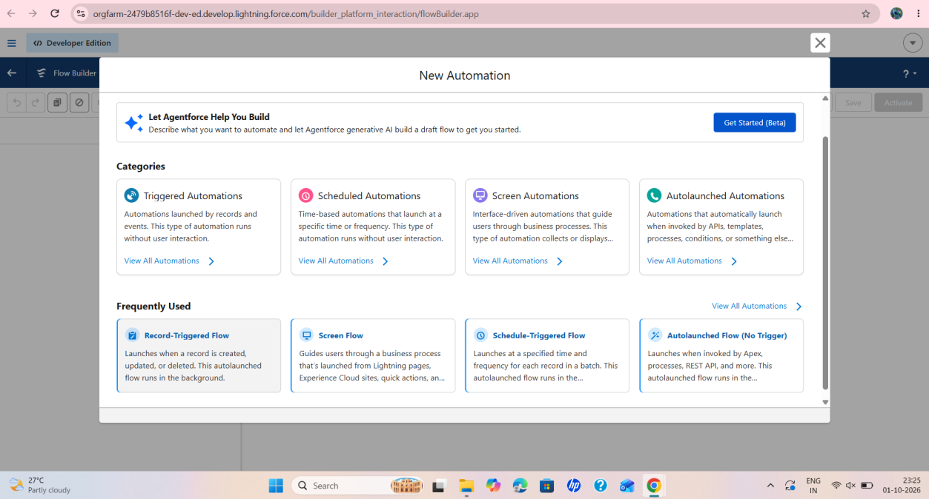
Figure 23: New Automation window
The New Automation window offers the Triggered Automations category and the Record-Triggered Flow type.
Step 4 : Select Vehicle Order Object. Trigger the Flow When: select Record is Created.
Set Entry Condition: All Conditions Are Met (AND); Field: Status__c; Operator: Equals; Value: Pending.
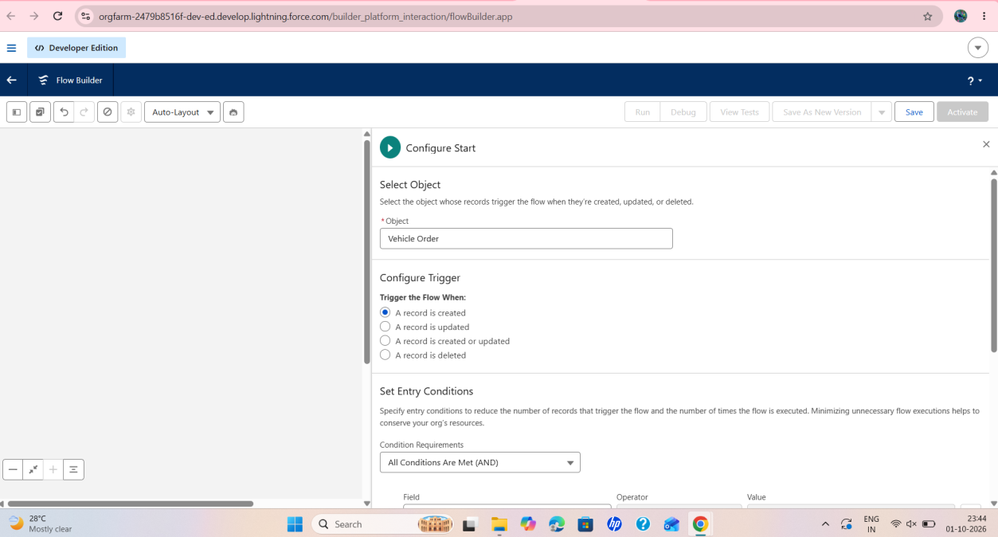
Figure 24: Flow start configuration
The flow is configured on the Vehicle Order object and is triggered when a record is created.
Step 5 : Click + → select Get Records.
Step 6 : Label: Get Customer Information. Object: Vehicle Customer. Condition – Field: Id; Operator: Equals; Value: {!$Record.Vehicle_Customer__c}.
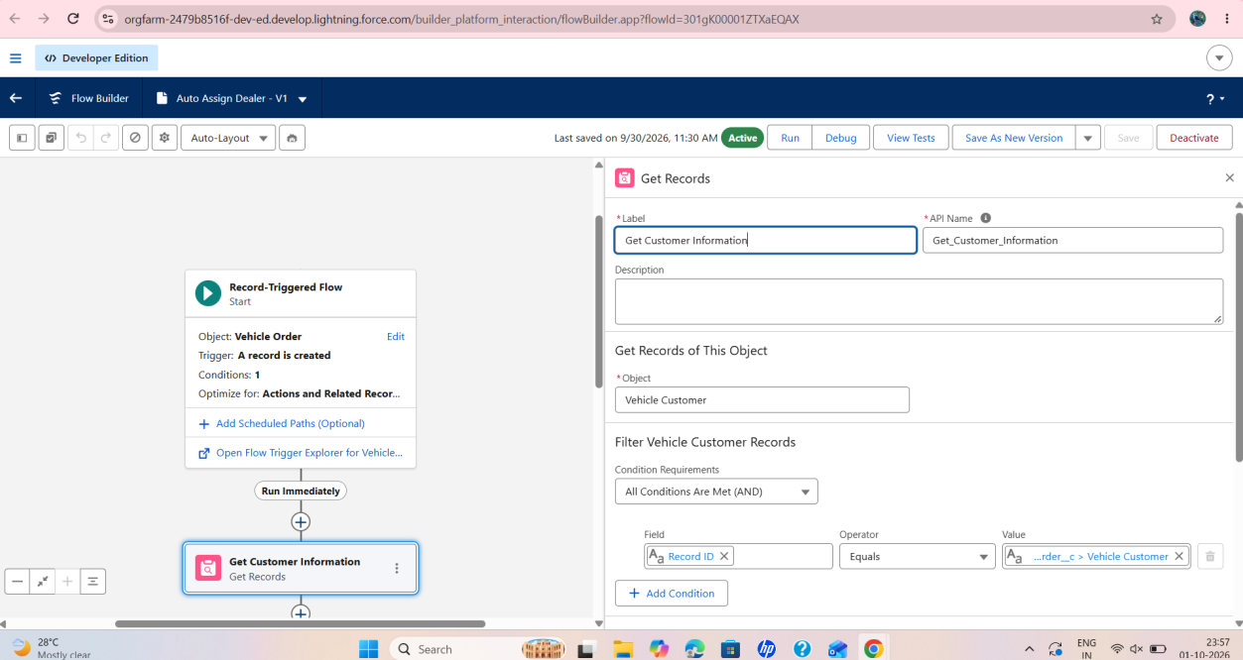
Figure 25: Get Customer Information
The Get Records element reads the Vehicle Customer record by matching the Id with the customer on the triggering order.
Step 7 : Click + → select Get Records. Label: Get Nearest Dealer. Object: Vehicle Dealer. Condition – Field: Dealer_Location__c; Operator: Equals; Value: {!Get_Customer_Information.Address__c}.
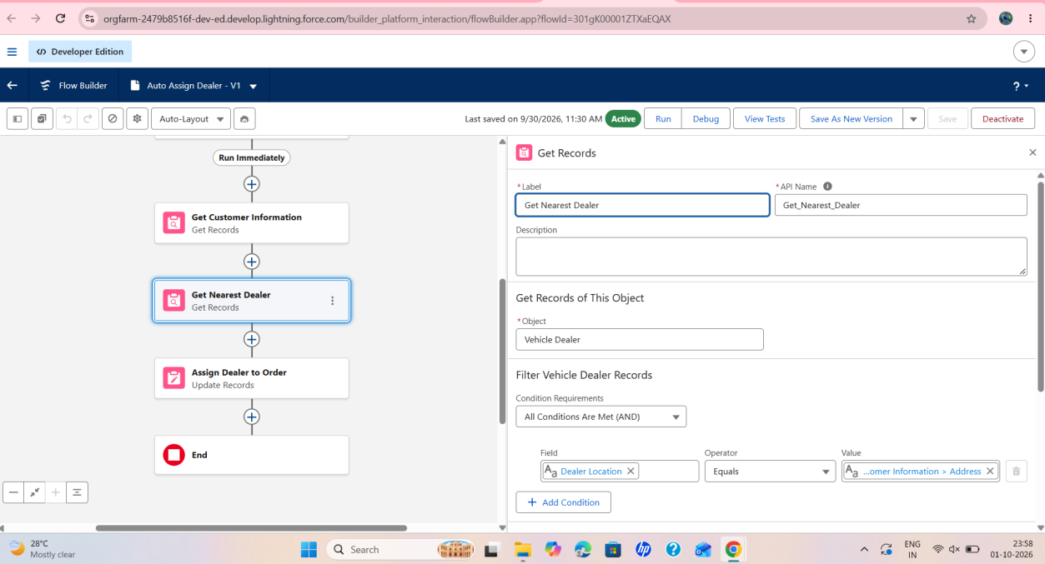
Figure 26: Get Nearest Dealer
The Get Records element searches Vehicle Dealer records whose Dealer Location equals the customer’s address.
Step 8 : Click + → select Update Records. Label: Assign Dealer to Order. How to Find Records to Update and Set Their Values: use the IDs and all field values from a record or record collection. Select Record(s) to Update: {!Get_Nearest_Dealer}.
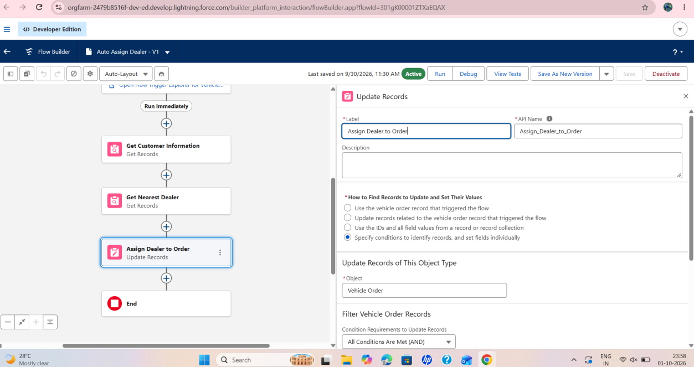
Figure 27: Assign Dealer to Order
The Update Records element “Assign Dealer to Order” is added after Get Nearest Dealer, on the Vehicle Order object.
Step 9 : Click Save and give the label name “Auto Assign Dealer”.
Step 10 : Activate the Flow.
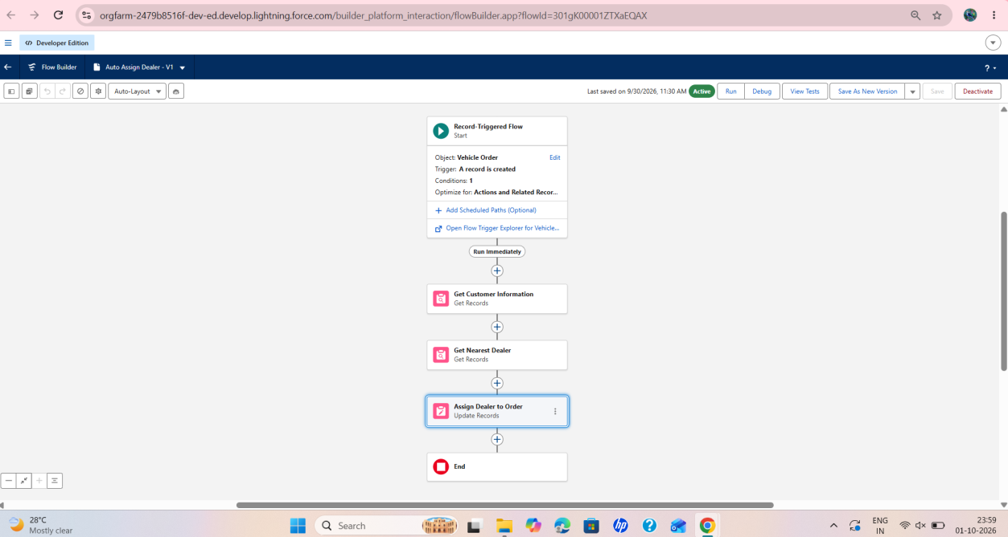
Figure 28: Auto Assign Dealer flow
The activated flow runs in the order Start → Get Customer Information → Get Nearest Dealer → Assign Dealer to Order → End.
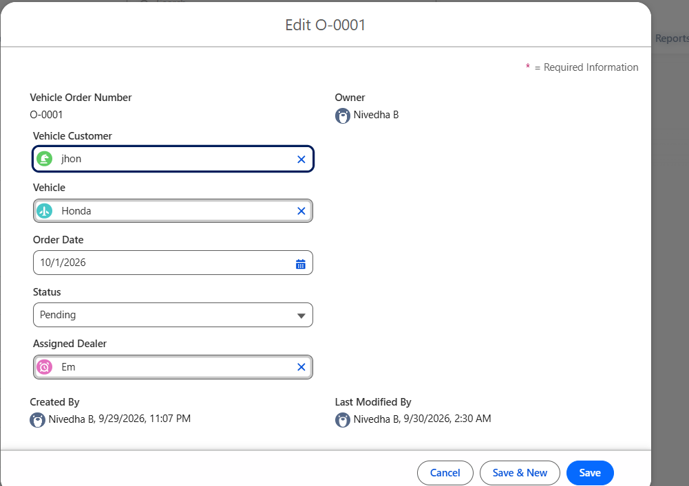
Figure 29: Order record with assigned dealer
An order record (O-0001) with a vehicle customer, vehicle, order date, status Pending and the Assigned Dealer field filled.

Flow 2: Creating a record-triggered flow to send an email to the customer reminding about the test drive
Step 1 : Select Record-Triggered Flow.
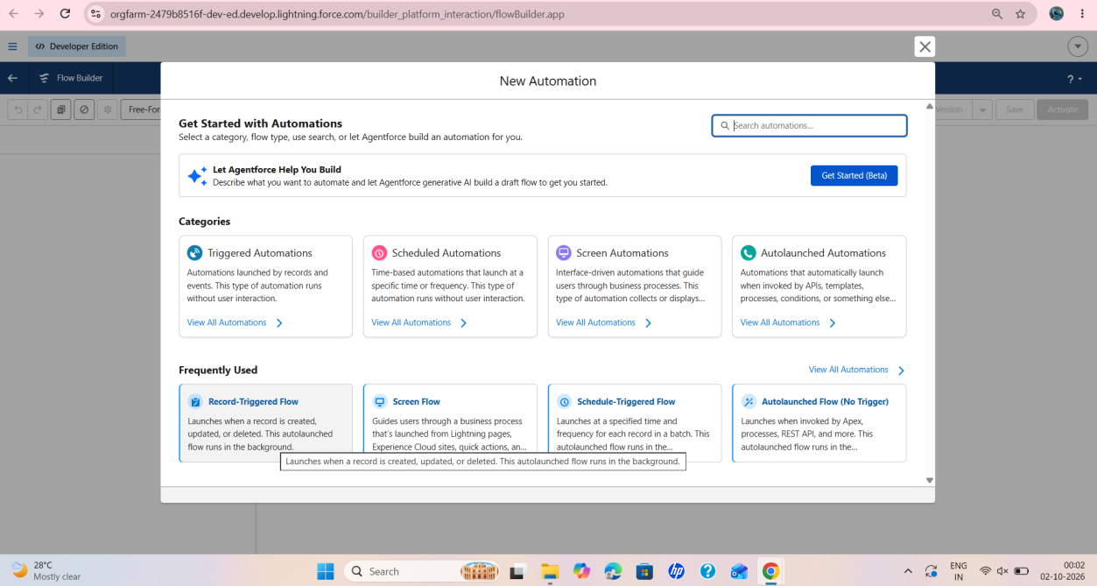
Figure 30: Selecting Record-Triggered Flow
The Record-Triggered Flow option is chosen from the New Automation window.
Step 2 : Select Vehicle Test Drive Object. Trigger the Flow When: a record is created or updated.
Set Entry Condition: All Conditions Are Met (AND); Field: Status__c; Operator: Equals; Value: Scheduled.
Step 3 : Click + Add Scheduled Paths (below the trigger). Label: Reminder Before Test Drive. Time Source: Test_Drive_Date__c. Offset Number: 1. Offset Options: Days Before. Click Done.
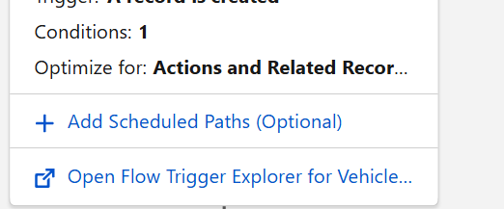
Figure 31: Add Scheduled Paths option
The “Add Scheduled Paths (Optional)” link below the flow trigger.
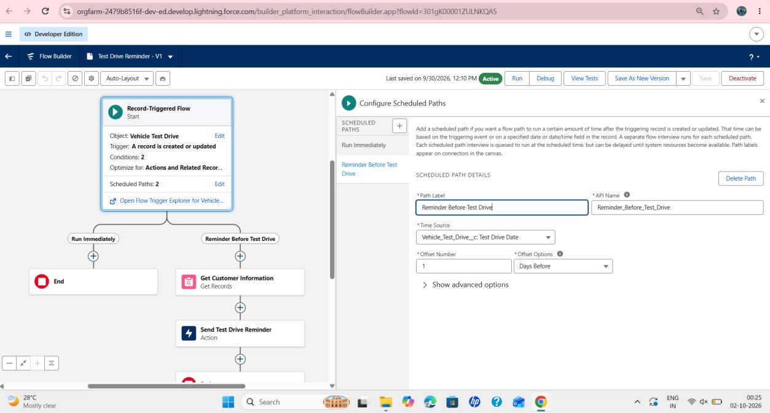
Figure 32: Scheduled path configuration
The scheduled path “Reminder Before Test Drive” uses the Test Drive Date as the time source with an offset of 1 day before.
Step 4 : Add the Get Records element:
1. Click + Add Element → Get Records.
2. Label: Get Customer Information.
3. Object: Vehicle_Customer__c.
4. Filter Conditions: Id = {!$Record.Vehicle_Customer__c}.
5. How Many Records to Store: select Only the first record.
6. How to Store Record Data: choose Automatically store all fields.
Step 5 : Send Reminder Email:
1. Click + Add Element → Action.
2. Action Type: Send Email.
3. Label: Send Test Drive Reminder.
4. Subject: “Reminder: Your Test Drive is Tomorrow!”.
5. Recipient Address List: {!Get_Customer_Information.Email__c}.
6. Rich-Text-Formatted Body: True.
7. Body: create a variable (Text Template resource).
8. API Name: EmailSent. Body text: “Dear {!Get_Customer_Information.Name}, This is a reminder that your test drive for {!$Record.Vehicle__c} is scheduled for tomorrow. If you need to reschedule, contact us at [Support Email]. Thank you, WhatNext Vision Motors Team”. Then set the Send Email Body to the EmailSent template.
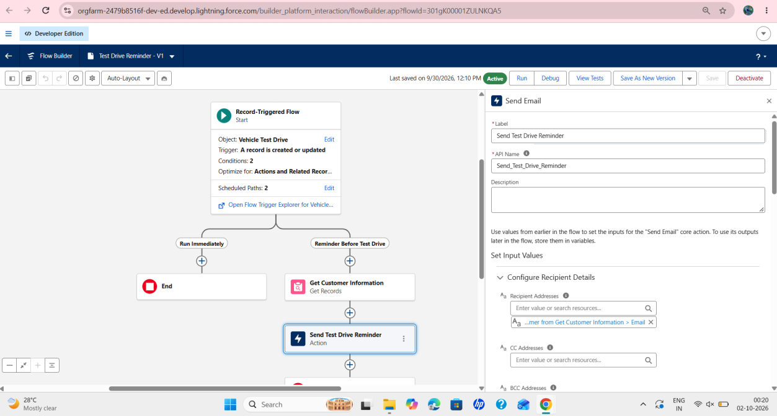
Figure 33: Send Email action
The Send Test Drive Reminder action is added on the scheduled path after Get Customer Information; the recipient comes from the customer’s email field.
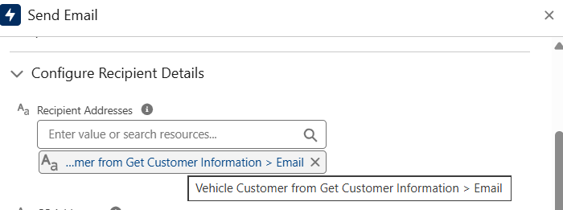
Figure 34: Recipient address
The recipient address is taken from the Email field of the Vehicle Customer record retrieved by Get Customer Information.
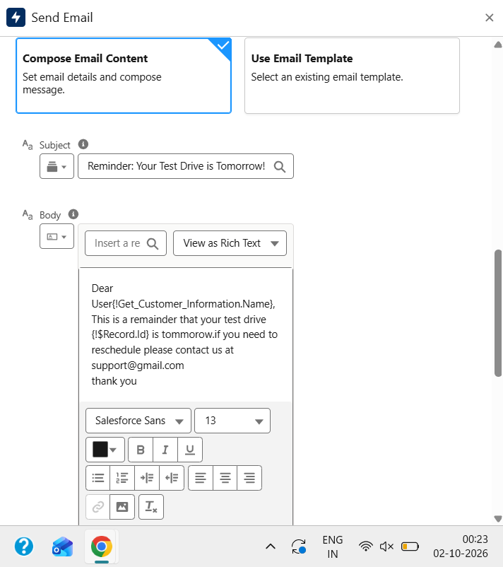
Figure 35: Subject and body of the email
The email is composed with the subject “Reminder: Your Test Drive is Tomorrow!” and a short body addressed to the customer.
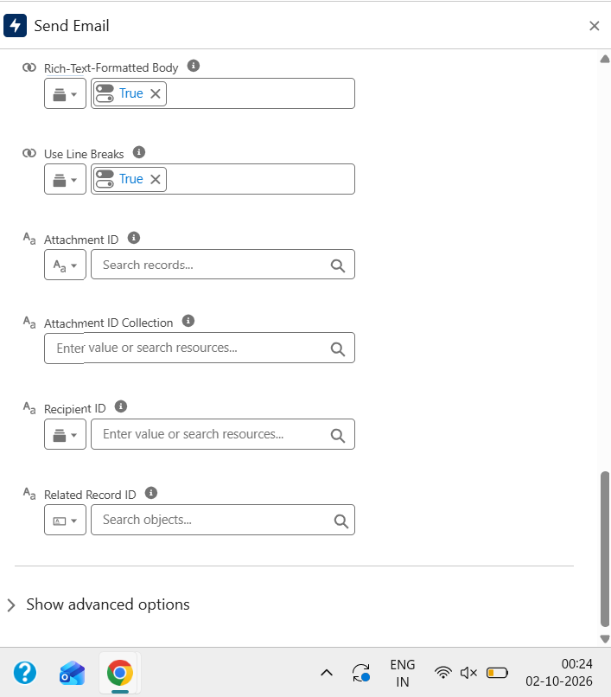
Figure 36: Rich-text and line-break options
Rich-Text-Formatted Body and Use Line Breaks are set to True in the Send Email action.
Step 6 : Click Save. Label Name: Test Drive Reminder.
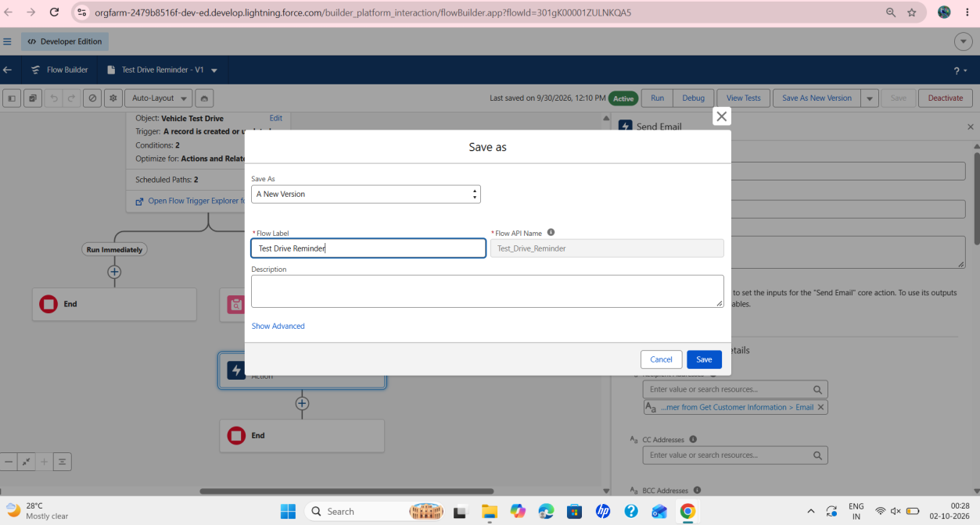
Figure 37: Save as – Test Drive Reminder
The flow is saved with the label “Test Drive Reminder”.
Step 7 : Activate the Flow.
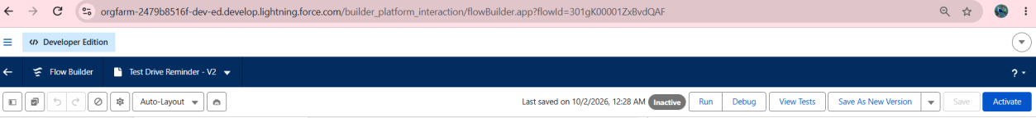
Figure 38: Activate option
The Activate button is used to activate the saved flow version.
Flow Page After Creation: the flow has the Run Immediately path and the Reminder Before Test Drive path, which runs Get Customer Information and Send Test Drive Reminder.
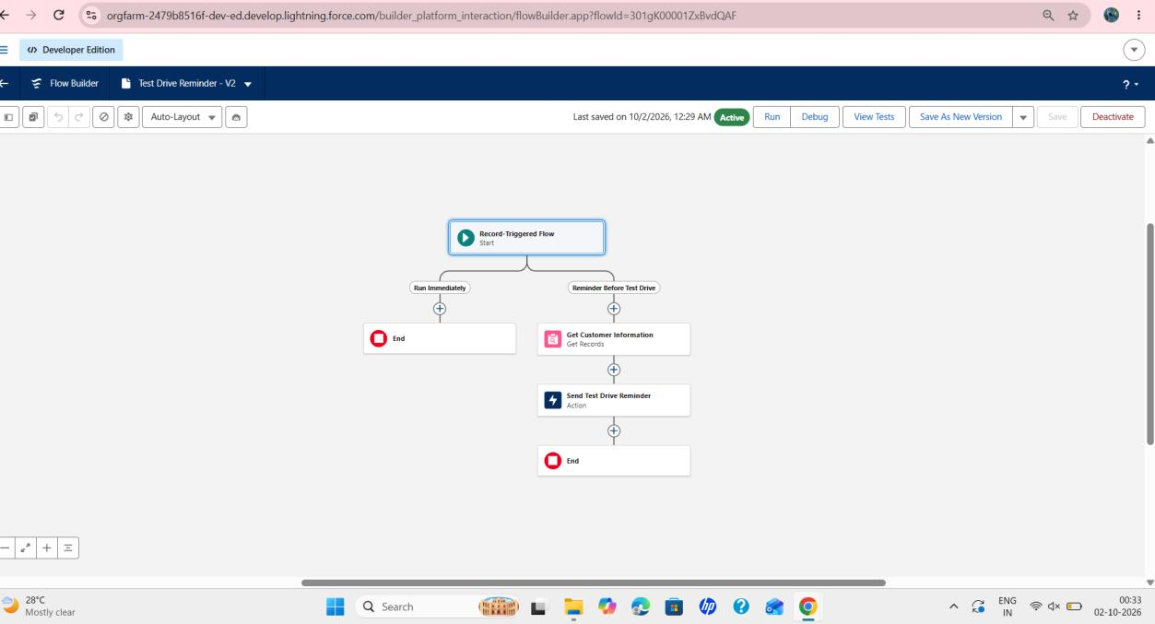
Figure 39: Completed Test Drive Reminder flow
The active flow after creation, showing both paths.
Test your Flow: after the flow is activated, check the customer’s inbox for the reminder email. The email addresses the customer by name and states that the test drive is scheduled for tomorrow, with details to contact if it needs to be rescheduled.

Features / Modules Involved
- Flow Builder, record-triggered flows, scheduled paths, Get Records, Update Records and the Send Email action.

Output / Result
Two flows were created and activated: Auto Assign Dealer assigns a dealer to a new order, and Test Drive Reminder emails the customer one day before a scheduled test drive.

Phase 7 : Apex, Trigger and Batch Jobs

Objective
To enforce the stock rules with an Apex trigger and handler class, and to process pending orders with a batch Apex job that is run by a scheduled job.

Activities Completed
- Step 1–4: Create the Apex handler class (VehicleOrderTriggerHandler)
- Step 5–7: Create the Apex trigger (VehicleOrderTrigger) and call the handler class
- Step 8: Create the batch job (VehicleOrderBatch)
- Step 9–11: Create the scheduler class, schedule the batch job and check the scheduled job

Implementation Details

Create Apex and Trigger Batch Jobs
Step 1 : Click Developer Console from the gear icon.
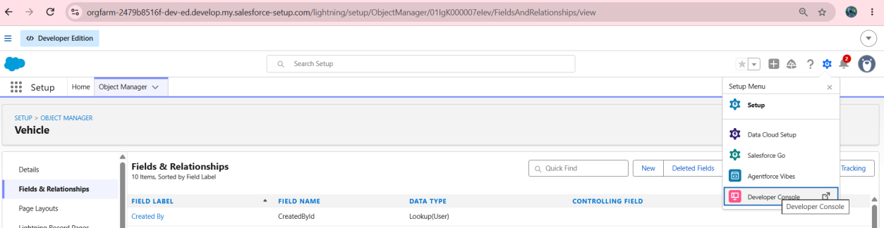
Figure 40: Opening the Developer Console
The Developer Console is opened from the Setup (gear) menu.
Step 2 : Click File, then select New, then select Apex Class.
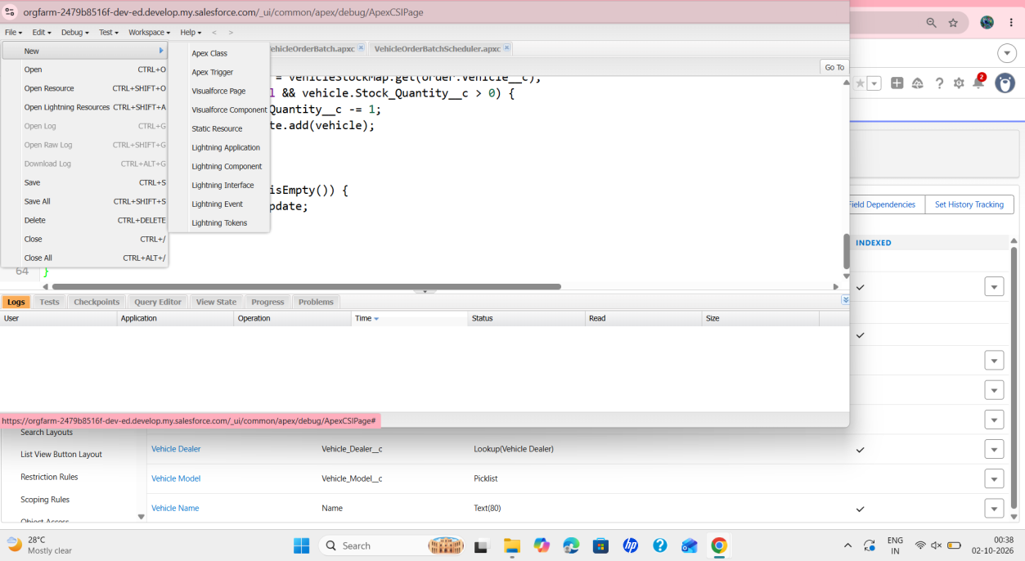
Figure 41: File → New menu
The File → New menu of the Developer Console lists Apex Class, Apex Trigger and other resources.
Step 3 : Give a name for the Apex class. Class Name: VehicleOrderTriggerHandler.
Step 4 : Write the Apex code.
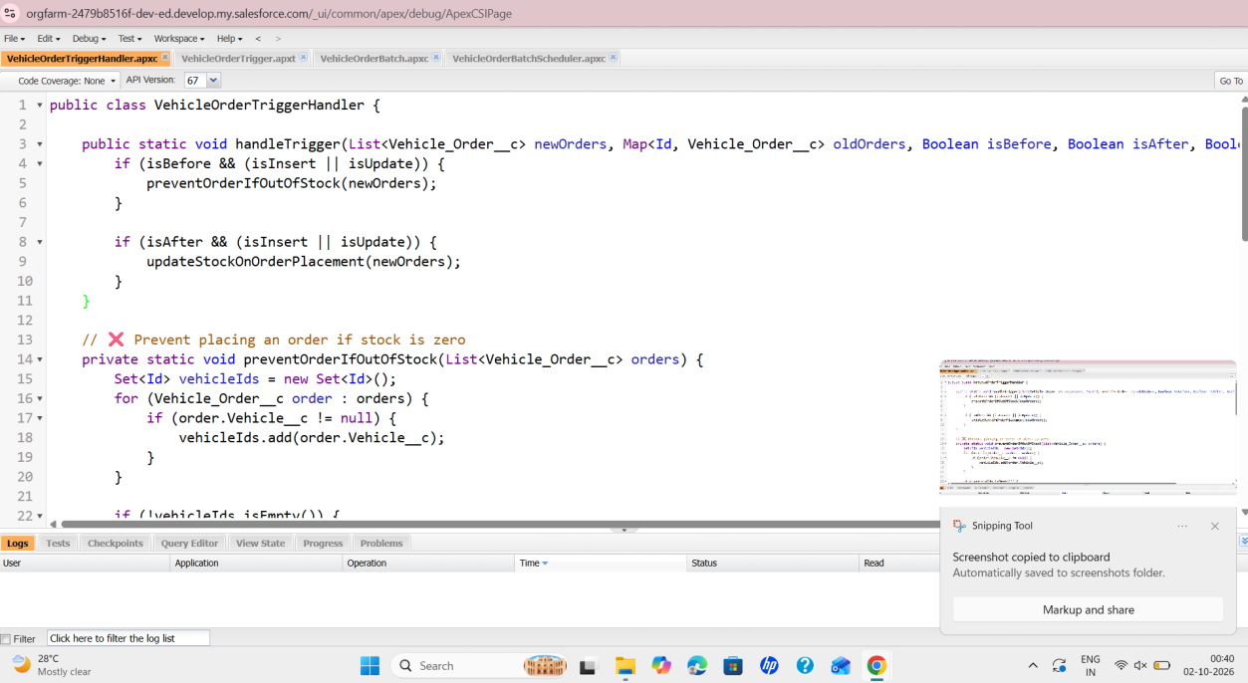
Figure 42: VehicleOrderTriggerHandler class
The handler class has handleTrigger, which calls preventOrderIfOutOfStock before save and updateStockOnOrderPlacement after save.
Source Code :
public class VehicleOrderTriggerHandler {

public static void handleTrigger(List<Vehicle_Order__c> newOrders, Map<Id, Vehicle_Order__c> oldOrders,
Boolean isBefore, Boolean isAfter, Boolean isInsert, Boolean isUpdate) {
if (isBefore) {
if (isInsert || isUpdate) {
preventOrderIfOutOfStock(newOrders);
}
}
if (isAfter) {
if (isInsert || isUpdate) {
updateStockOnOrderPlacement(newOrders);
}
}
}

// Method to prevent orders when the vehicle is out of stock
private static void preventOrderIfOutOfStock(List<Vehicle_Order__c> orders) {
Set<Id> vehicleIds = new Set<Id>();
for (Vehicle_Order__c order : orders) {
if (order.Vehicle__c != null) {
vehicleIds.add(order.Vehicle__c);
}
}
if (!vehicleIds.isEmpty()) {
Map<Id, Vehicle__c> vehicleStockMap = new Map<Id, Vehicle__c>();
for (Vehicle__c vehicle : [SELECT Id, Stock_Quantity__c FROM Vehicle__c WHERE Id IN :vehicleIds]) {
vehicleStockMap.put(vehicle.Id, vehicle);
}
for (Vehicle_Order__c order : orders) {
if (vehicleStockMap.containsKey(order.Vehicle__c)) {
Vehicle__c vehicle = vehicleStockMap.get(order.Vehicle__c);
if (vehicle.Stock_Quantity__c <= 0) {
order.addError('This vehicle is out of stock. Order cannot be placed.');
}
}
}
}
}

// Method to update vehicle stock when an order is placed
private static void updateStockOnOrderPlacement(List<Vehicle_Order__c> orders) {
Set<Id> vehicleIds = new Set<Id>();
for (Vehicle_Order__c order : orders) {
if (order.Vehicle__c != null && order.Status__c == 'Confirmed') {
vehicleIds.add(order.Vehicle__c);
}
}
if (!vehicleIds.isEmpty()) {
Map<Id, Vehicle__c> vehicleStockMap = new Map<Id, Vehicle__c>();
for (Vehicle__c vehicle : [SELECT Id, Stock_Quantity__c FROM Vehicle__c WHERE Id IN :vehicleIds]) {
vehicleStockMap.put(vehicle.Id, vehicle);
}
List<Vehicle__c> vehiclesToUpdate = new List<Vehicle__c>();
for (Vehicle_Order__c order : orders) {
if (vehicleStockMap.containsKey(order.Vehicle__c)) {
Vehicle__c vehicle = vehicleStockMap.get(order.Vehicle__c);
if (vehicle.Stock_Quantity__c > 0) {
vehicle.Stock_Quantity__c -= 1;
vehiclesToUpdate.add(vehicle);
}
}
}
if (!vehiclesToUpdate.isEmpty()) {
update vehiclesToUpdate;
}
}
}
}

The error message shown to the user when an order is placed for a vehicle with zero stock is: “This vehicle is out of stock. Order cannot be placed.”
Step 5 : Write Trigger Handler – click File → New → Apex Trigger.
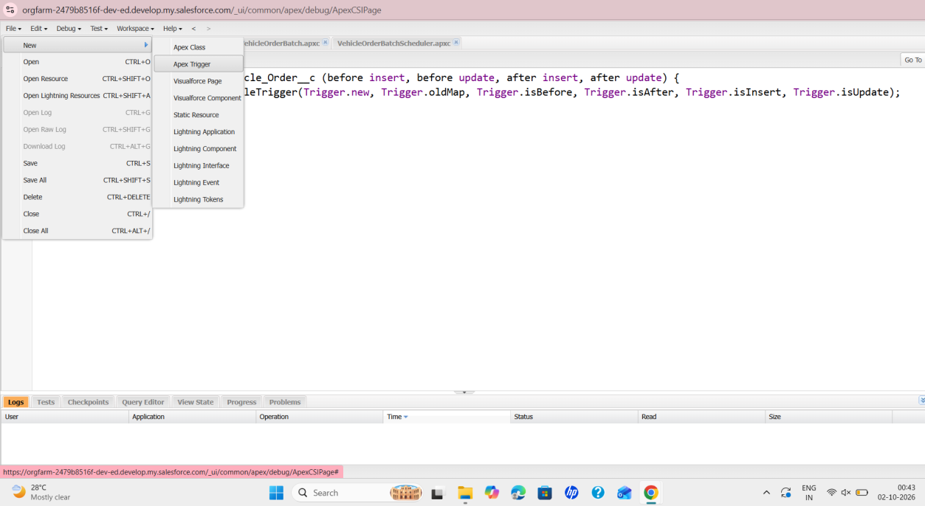
Figure 43: File → New → Apex Trigger
The Apex Trigger option is chosen from the File → New menu of the Developer Console.
Step 6 : Write the trigger class name and select the Vehicle Order object. Trigger name: VehicleOrderTrigger; sObject: Vehicle_Order__c.
Step 7 : Call the Apex class in the trigger class.
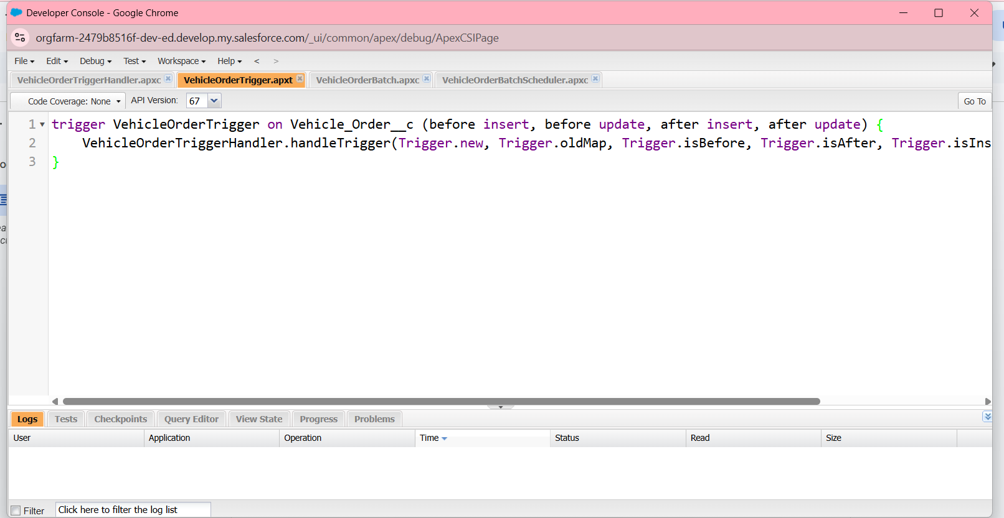
Figure 44: VehicleOrderTrigger
The trigger on Vehicle_Order__c runs before insert, before update, after insert and after update, and calls VehicleOrderTriggerHandler.handleTrigger.
Source Code :
trigger VehicleOrderTrigger on Vehicle_Order__c (before insert, before update, after insert, after update) {
VehicleOrderTriggerHandler.handleTrigger(Trigger.new, Trigger.oldMap, Trigger.isBefore,
Trigger.isAfter, Trigger.isInsert, Trigger.isUpdate);
}

Step 8 : Create Batch Job.
A customer places an order, but the vehicle is out of stock.
- The order remains pending.
- After new stock is added, the batch job updates the order to confirmed.
Create a new Apex class named VehicleOrderBatch (File → New → Apex Class). The batch class selects all orders whose status is Pending, checks the stock of the related vehicles and, where stock is available, sets the order status to Confirmed and reduces the vehicle stock by one.
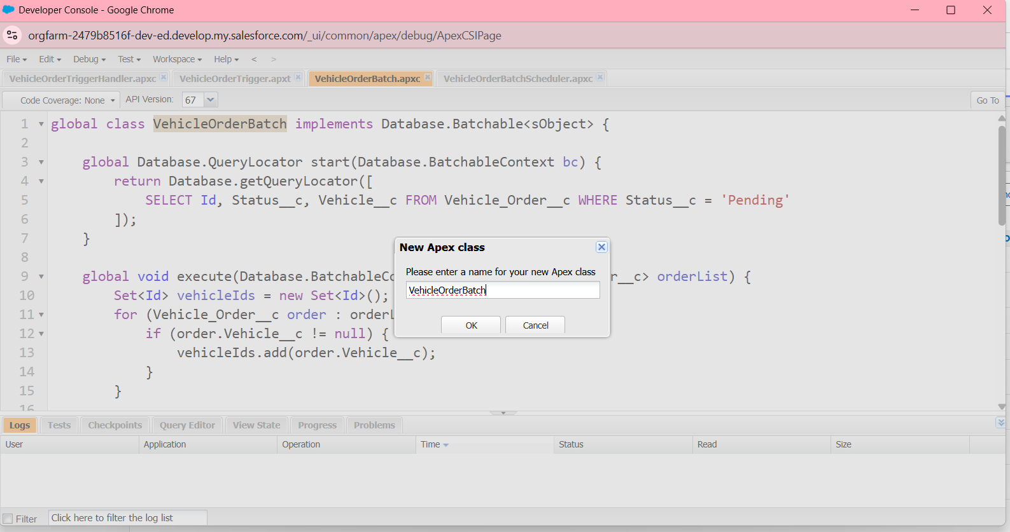
Figure 45: New Apex class – VehicleOrderBatch
The class name VehicleOrderBatch is entered in the New Apex class dialog.
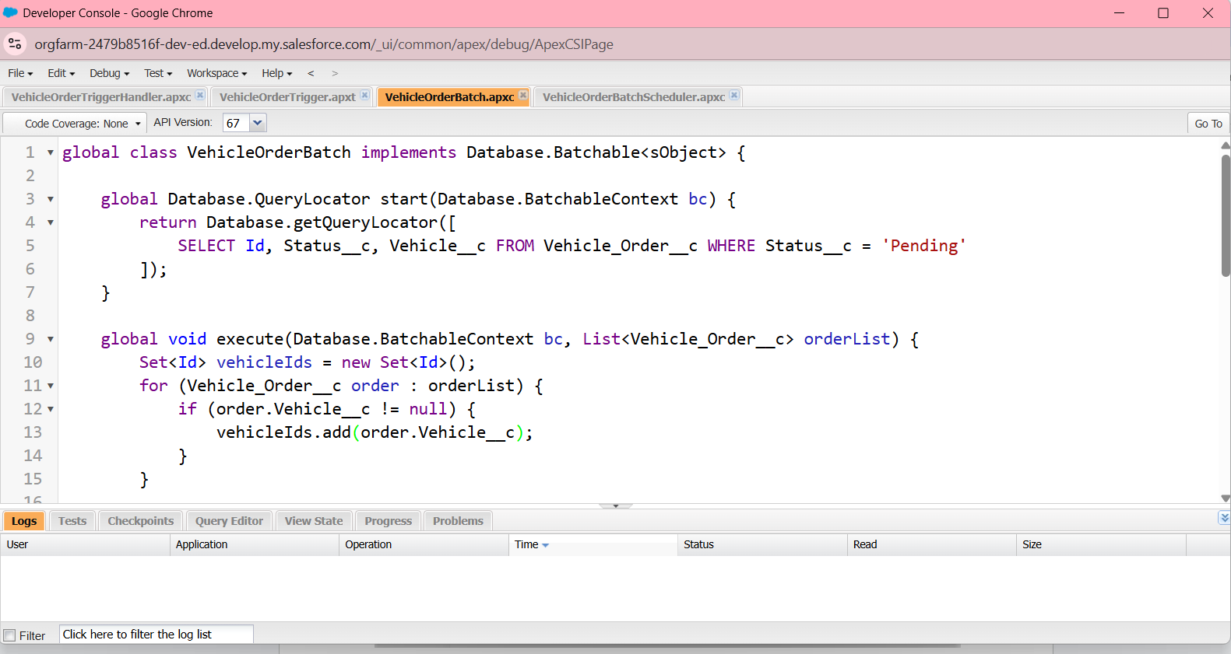
Figure 46: VehicleOrderBatch class
The batch class implements Database.Batchable; its start method queries Vehicle_Order__c records where Status__c is Pending.
Source Code :
global class VehicleOrderBatch implements Database.Batchable<sObject> {

global Database.QueryLocator start(Database.BatchableContext bc) {
return Database.getQueryLocator([
SELECT Id, Status__c, Vehicle__c
FROM Vehicle_Order__c
WHERE Status__c = 'Pending'
]);
}

global void execute(Database.BatchableContext bc, List<Vehicle_Order__c> orderList) {
Set<Id> vehicleIds = new Set<Id>();
for (Vehicle_Order__c order : orderList) {
if (order.Vehicle__c != null) {
vehicleIds.add(order.Vehicle__c);
}
}
if (!vehicleIds.isEmpty()) {
Map<Id, Vehicle__c> vehicleStockMap = new Map<Id, Vehicle__c>();
for (Vehicle__c vehicle : [SELECT Id, Stock_Quantity__c FROM Vehicle__c WHERE Id IN :vehicleIds]) {
vehicleStockMap.put(vehicle.Id, vehicle);
}
List<Vehicle_Order__c> ordersToUpdate = new List<Vehicle_Order__c>();
List<Vehicle__c> vehiclesToUpdate = new List<Vehicle__c>();
for (Vehicle_Order__c order : orderList) {
if (vehicleStockMap.containsKey(order.Vehicle__c)) {
Vehicle__c vehicle = vehicleStockMap.get(order.Vehicle__c);
if (vehicle.Stock_Quantity__c > 0) {
order.Status__c = 'Confirmed';
vehicle.Stock_Quantity__c -= 1;
ordersToUpdate.add(order);
vehiclesToUpdate.add(vehicle);
}
}
}
if (!ordersToUpdate.isEmpty()) {
update ordersToUpdate;
}
if (!vehiclesToUpdate.isEmpty()) {
update vehiclesToUpdate;
}
}
}

global void finish(Database.BatchableContext bc) {
System.debug('Vehicle order batch job completed.');
}
}

Step 9 : Create the Schedule Class, then invoke the Batch Class in the Schedule Class. Class name: VehicleOrderBatchScheduler.
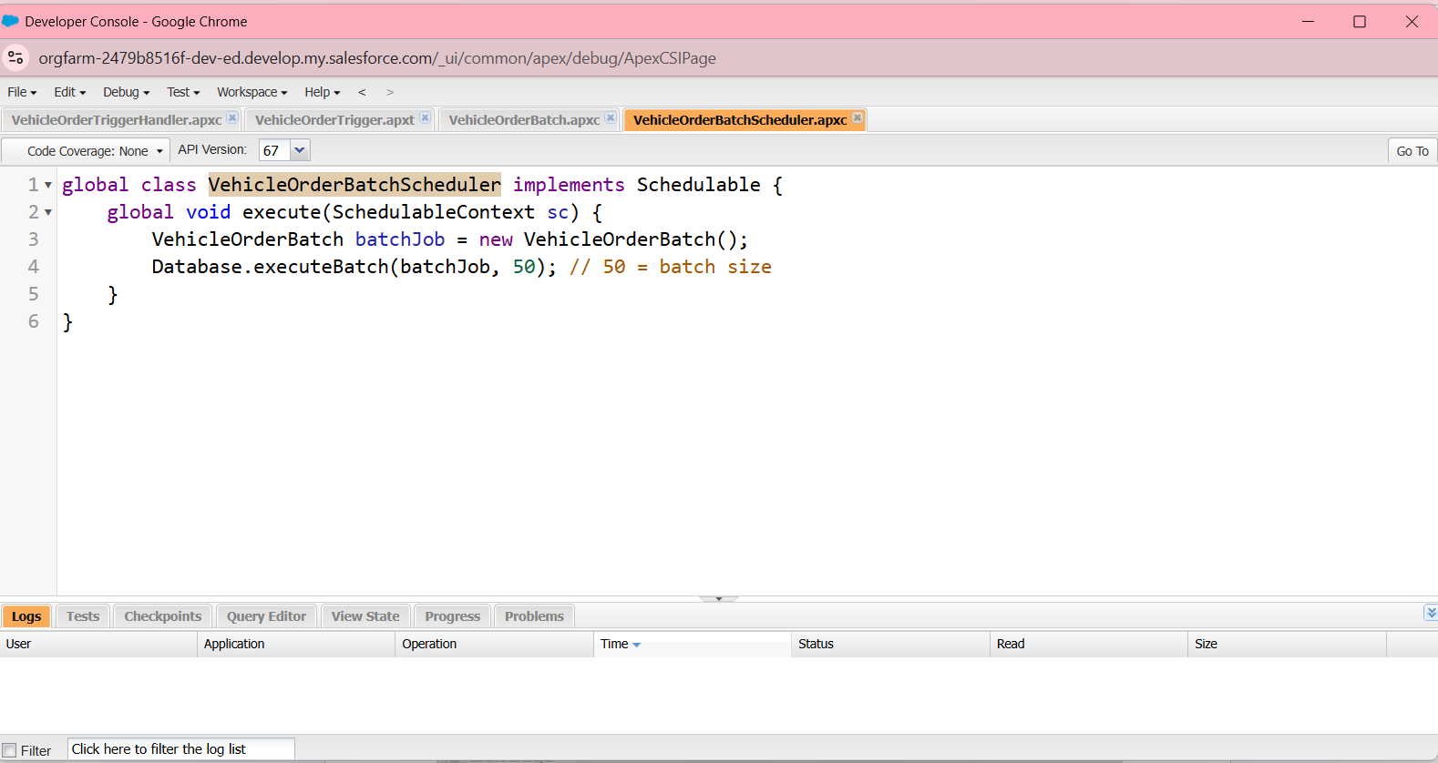
Figure 47: VehicleOrderBatchScheduler class
The scheduler class implements Schedulable; its execute method runs VehicleOrderBatch with a batch size of 50.
Source Code :
global class VehicleOrderBatchScheduler implements Schedulable {
global void execute(SchedulableContext sc) {
VehicleOrderBatch batchJob = new VehicleOrderBatch();
Database.executeBatch(batchJob, 50); // 50 is the batch size
}
}

Step 10 : Schedule the Batch Job. The batch job is scheduled using the Execute Anonymous window (Debug → Open Execute Anonymous Window). The reference states that the job runs every night at midnight; the cron expression used runs it daily at 12:00 PM.
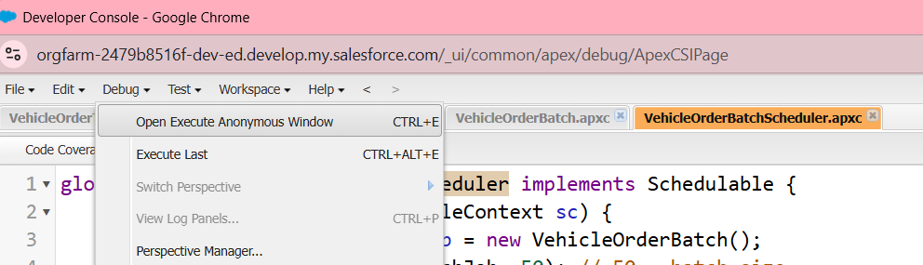
Figure 48: Open Execute Anonymous Window
The Debug menu of the Developer Console provides the “Open Execute Anonymous Window” option.
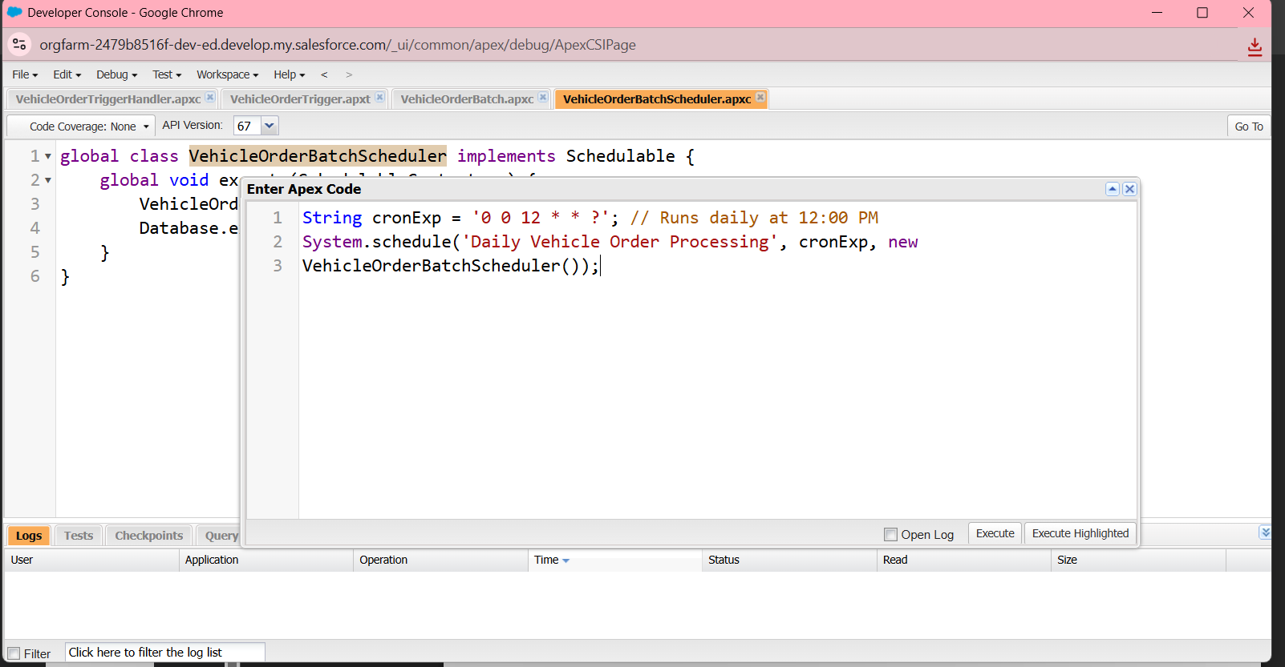
Figure 49: Scheduling the batch job
The cron expression and the System.schedule call register “Daily Vehicle Order Processing”.
Source Code :
String cronExp = '0 0 12 * * ?'; // Runs daily at 12:00 PM
System.schedule('Daily Vehicle Order Processing', cronExp, new VehicleOrderBatchScheduler());

Step 11 : You can check where this scheduled job is running in Setup → Scheduled Jobs.
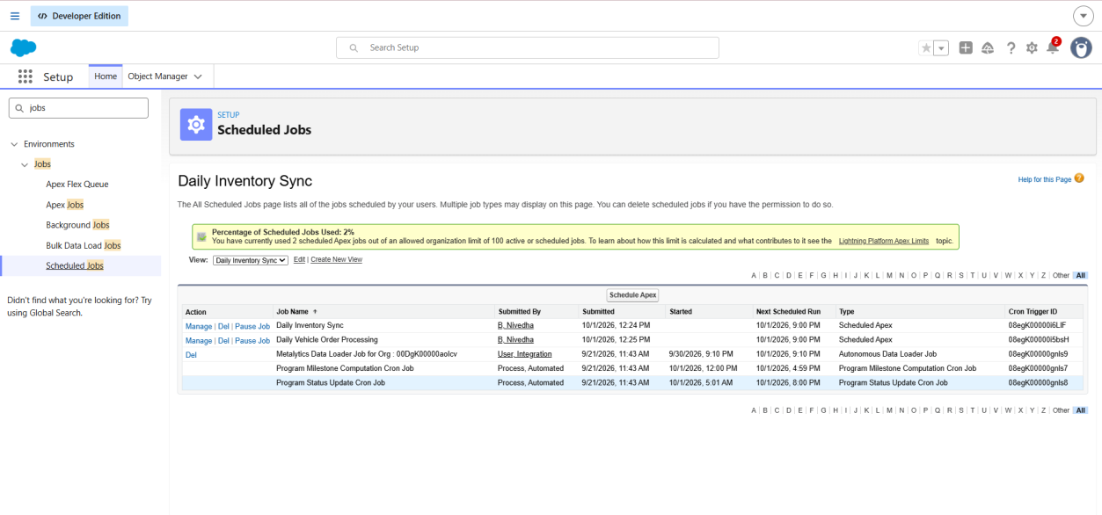
Figure 50: Scheduled Jobs page
“Daily Vehicle Order Processing” is listed as a Scheduled Apex job with its submitted time and next scheduled run.

Features / Modules Involved
- Developer Console, Apex classes, Apex trigger with a trigger handler, Batch Apex, Schedulable Apex and Scheduled Jobs.

Output / Result
Orders for vehicles with no stock are blocked with an error message, stock is reduced when an order is confirmed, and the scheduled batch job processes Pending orders every day and confirms them once stock is available.

Conclusion
The WhatNext Vision Motors project was implemented phase by phase in a Salesforce Developer Edition org. The data model of custom objects was exposed through tabs and a Lightning app and extended with fields and relationships. Record-triggered flows automate dealer assignment and test drive reminders, while an Apex trigger, handler class, batch job and scheduler enforce stock rules and process pending orders. Together these components deliver a more efficient ordering process and reduce manual work for staff.
Thank you

